ASSIGNMENT TITLE
Design, Simulate and Evaluate an End-to-End Analog and Digital Communication System for Broadcast, Digital Voice and Next-Generation Wireless Networks

A. ASSIGNMENT INFORMATION
Particular | Details
Department | Electronics and Communication Engineering
Programme | B.E./B.Tech – Electronics and Communication Engineering
Course Code | ECA0804
Course Name | Analog and Digital Communication
Academic Year | 2026–2027
Assignment Type | Common Course Assignment
Assignment Title | Design, Simulate and Evaluate an End-to-End Analog and Digital Communication System for Broadcast, Digital Voice and Next-Generation Wireless Networks
Maximum Marks | 100
CO1 | Understand and analyse analog communication systems
CO2 | Analyse FM/PM and noise performance
CO3 | Apply sampling, quantization, PCM and pulse techniques
CO4 | Analyse digital modulation, BER and signal-space concepts
CO5 | Apply coding, multiplexing, spread spectrum and modern communication concepts
Bloom's Level | L6 – Create
Supporting Levels | L4 – Analyse, L5 – Evaluate
SDG | SDG 9 – Industry, Innovation and Infrastructure

B. ASSIGNMENT PROBLEM / CHALLENGE
Modern communication networks must support different types of services including AM radio broadcasting, analog television, FM audio broadcasting, digital voice and wireless data services. Each service has different requirements for bandwidth, power, reliability, data rate and noise performance.
A regional communication service provider requires an integrated communication system that can support:
- AM radio broadcasting
- Analog television transmission
- FM audio broadcasting
- Digitized voice communication for 250–300 subscribers
- Digital wireless communication
- Next-generation cellular and IoT services
- Remote users operating under fading and multipath conditions
The challenge is to develop a unified communication architecture that combines analog and digital communication techniques and evaluates the performance of the system under practical channel conditions.
The system must include:
- Basic communication-system architecture
- FDM
- DSB-SC and SSB-SC
- VSB-SC for television
- Superheterodyne AM receiver
- FM and PM
- Carson's bandwidth rule
- Pre-emphasis and de-emphasis
- Sampling and Nyquist criterion
- Quantization and encoding
- PCM, DPCM, DM, ADM and ADPCM
- Nyquist zero-ISI pulse shaping
- Eye-pattern analysis
- ASK, FSK, BPSK, QPSK and QAM
- Signal-space representation
- BER analysis
- Channel coding
- Spread spectrum and CDMA
- GSM and multiple-access techniques
- TDM/FDM
- Equalization
- VoIP, DSL, optical fibre, 5G and IoT communication concepts
The system must be simulated and validated using at least four controlled test scenarios including AWGN, multipath/fading, co-channel/adjacent-channel interference and bandwidth-limited/coarse-quantization conditions.

C. PROBLEM STATEMENT
The problem is to design and simulate an end-to-end analog and digital communication system for a regional communication provider.
The proposed system should receive different information sources such as audio, video, voice and binary data. The signals must be appropriately processed, modulated, multiplexed and transmitted through a communication channel.
The channel may introduce:
- Additive noise
- Multipath fading
- Inter-symbol interference
- Co-channel interference
- Adjacent-channel interference
- Bandwidth limitation
- Quantization noise
At the receiver, the transmitted signals must be recovered using suitable demodulation, decoding, filtering and equalization techniques.
The final system should be evaluated using measurable parameters such as:
- Bandwidth
- Modulation efficiency
- Output SNR
- SQNR
- BER
- Eye opening
- ISI margin
- Spectral efficiency
- Coding gain
- Power efficiency
- Image Rejection Ratio
The objective is to identify suitable communication techniques for different services and make an engineering decision based on performance, bandwidth, power and reliability.

D. REQUIREMENTS AND CONSTRAINTS
D.1 Functional Requirements
The proposed system shall:
- Implement a basic communication-system architecture.
- Demonstrate frequency division multiplexing.
- Implement DSB-SC modulation and demodulation.
- Implement SSB-SC modulation and demodulation.
- Analyse VSB-SC for analog television.
- Implement a superheterodyne AM receiver.
- Implement FM and PM.
- Calculate FM bandwidth using Carson's Rule.
- Analyse pre-emphasis and de-emphasis.
- Apply sampling according to the Nyquist criterion.
- Implement quantization and encoding.
- Analyse PCM, DPCM, DM, ADM and ADPCM.
- Implement Nyquist pulse shaping for zero ISI.
- Generate and analyse eye diagrams.
- Implement ASK, FSK, BPSK and QPSK.
- Analyse QAM for high-data-rate communication.
- Represent digital signals using signal-space diagrams.
- Calculate and compare BER performance.
- Implement channel coding techniques.
- Analyse spread spectrum, CDMA, GSM, TDM and FDM.
- Analyse multipath effects and equalization.
- Relate the system to VoIP, DSL, optical fibre, 5G and IoT applications.
D.2 Performance Requirements
The system should be evaluated using:
Parameter | Requirement
Bandwidth | Calculate and compare occupied bandwidth
SNR | Measure received signal quality
SQNR | Evaluate quantization quality
BER | Measure digital communication errors
Eye Opening | Evaluate ISI
Spectral Efficiency | Compare data rate per bandwidth
Coding Gain | Evaluate error-correction improvement
Power Efficiency | Compare transmission efficiency
Modulation Efficiency | Evaluate modulation performance
IRR | Evaluate AM receiver selectivity
D.3 Test Requirements
Test | Condition | Main Parameter
Test 1 | AWGN | SNR and BER
Test 2 | Multipath/Fading | BER and eye opening
Test 3 | Co-channel/Adjacent interference | SNR and interference level
Test 4 | Bandwidth limitation/Coarse quantization | SQNR and reconstructed signal quality

D.4 Technical Constraints
The system design must consider:
- Limited bandwidth
- Noise
- Interference
- Multipath propagation
- Fading
- ISI
- Quantization noise
- Power consumption
- Modulation complexity
- Coding overhead
- Receiver complexity
- Spectrum availability
- Wireless reliability
D.5 Software Requirements
The proposed system can be implemented using:
- MATLAB
- Simulink
- Communications Toolbox
- Signal Processing Toolbox
- Spectrum analysis tools
- Eye diagram tools
- Constellation diagram tools

E. STUDENT WORK
E.1 Problem Understanding and Formulation
The proposed system integrates analog and digital communication techniques into a common end-to-end architecture.
The overall communication process is:
Information Source → Signal Processing → Modulation → Multiplexing → Channel → Demodulation → Demultiplexing → Signal Reconstruction → Destination
The system supports audio, video, voice and digital data.
E.2 Application of Course Knowledge
Analog Communication
AM, DSB-SC, SSB-SC, VSB-SC, FM and PM are used for broadcast and analog communication applications.
Digital Communication
Sampling, quantization, PCM, DPCM, DM, ADM and ADPCM are used to convert analog voice into digital information.
Digital Modulation
ASK, FSK, BPSK, QPSK and QAM are analysed for digital data transmission.
Multiplexing
FDM is used for frequency-based channel allocation, while TDM is used for sharing a communication channel among multiple digital users.
Channel Coding
Block codes, cyclic codes and convolutional codes are considered for improving transmission reliability.
Wireless Communication
Spread spectrum, CDMA, GSM, equalization and next-generation wireless concepts are incorporated into the proposed design.
These concepts directly correspond to the CO1–CO5 requirements specified for ECA0804.
E.3 Proposed System Architecture
Information Sources
↓
Audio / Video / Voice & Data
↓
AM/FM / VSB / ADC & Sampling
↓
Analog / Digital / Wireless Modulation
↓
FDM / TDM Multiplexer
↓
Communication Channel
↓
AWGN / Fading / Interference
↓
Receiver
↓
Demodulation & Equalization
↓
Decoding & Demultiplexing
↓
Signal Reconstruction
↓
Destination

E.4 Analog Communication Design
AM Communication
The AM signal is represented as:
s(t) = Ac[1 + μm(t)]cos(2πfct)
where:
- Ac = carrier amplitude
- μ = modulation index
- m(t) = message signal
- fc = carrier frequency
AM is used for radio broadcasting.
DSB-SC
The DSB-SC signal is:
s(t) = Ac m(t) cos(2πfct)
The carrier is suppressed, resulting in improved power efficiency.
SSB-SC
Only one sideband is transmitted. Therefore, the bandwidth requirement is approximately equal to the highest message frequency.
VSB-SC
VSB transmits one complete sideband and a small portion of the other sideband. It is suitable for television broadcasting.

E.5 FM and PM Design
For FM:
sFM(t) = Ac cos[2πfct + β sin(2πfmt)]
where β represents the modulation index.
Using Carson's Rule:
BWFM ≈ 2(Δf + fm)
FM provides improved resistance to amplitude noise.
PM changes the phase of the carrier according to the message signal.
Pre-emphasis is applied at the transmitter and de-emphasis at the receiver to improve high-frequency noise performance.

E.6 Digital Voice Communication
The voice signal is converted into digital form using:
Analog Voice → Sampling → Quantization → Encoding → Digital Bits
The Nyquist criterion is:
fs ≥ 2fm
PCM is used to represent each quantized sample as a binary word.
For 300 subscribers, multiplexing can be used to combine individual digital voice streams into a common transmission channel.

E.7 Digital Modulation Design
The digital bit stream is converted into modulated signals using ASK, FSK, BPSK, QPSK and QAM.
BPSK
Binary phase shift keying uses two carrier phases to represent binary data.
QPSK
QPSK uses four different phases and can transmit two bits per symbol.
QAM
QAM uses both amplitude and phase variations and provides high spectral efficiency.
The performance is evaluated using BER and constellation diagrams.

E.8 Channel Coding and Equalization
Channel coding introduces redundancy into the transmitted data so that errors can be detected and corrected.
The proposed system considers:
- Block coding
- Cyclic coding
- Convolutional coding
Equalization is applied to reduce the effects of multipath propagation and inter-symbol interference.

E.9 Multiplexing
FDM divides the available bandwidth into separate frequency channels.
TDM allocates separate time slots to different users.
For the proposed multi-user voice system, TDM can be used to combine several digital voice streams before transmission.

4. USE OF MODERN TOOLS
MATLAB and Simulink are used to model and simulate the complete communication system.
MATLAB can be used for:
- Signal generation
- AM/FM/PM simulation
- Sampling
- Quantization
- PCM encoding
- Digital modulation
- BER calculation
- FFT and spectrum analysis
- Eye diagrams
- Constellation diagrams
- SNR and SQNR calculation
- Channel modelling
- Performance comparison
Simulink can be used to create a block-level representation of the complete transmitter-channel-receiver system.
The simulation environment enables controlled changes in noise, interference, fading, bandwidth and quantization levels.

5. RESULTS AND VALIDATION
5.1 Simulation Results
The simulation generates:
- AM waveform
- DSB-SC spectrum
- SSB-SC spectrum
- VSB spectrum
- FM waveform
- PM waveform
- Sampled signal
- Quantized signal
- PCM signal
- Digital modulation waveforms
- Eye diagram
- QAM constellation
- BER versus SNR graph
- Transmitted and received waveforms
5.2 Test Scenario 1 – AWGN
AWGN is added to the communication channel.
Observation: Increasing noise power decreases SNR and increases BER.
Result: Higher SNR provides improved signal recovery and lower BER.
5.3 Test Scenario 2 – Multipath/Fading
A fading channel is introduced to simulate wireless multipath propagation.
Observation: The received signal experiences amplitude and phase variations.
Result: Equalization and channel coding improve the reliability of communication.
5.4 Test Scenario 3 – Interference
Co-channel and adjacent-channel interference are introduced.
Observation: Interference reduces the received signal quality and increases BER.
Result: Proper filtering, guard bands, channel allocation and receiver selectivity reduce interference.
5.5 Test Scenario 4 – Bandwidth and Quantization
The available bandwidth is reduced and the number of quantization levels is decreased.
Observation: Bandwidth limitation causes signal distortion, while coarse quantization increases quantization noise.
Result: Proper bandwidth allocation and sufficient quantization levels improve signal reconstruction.

5.6 Performance Metrics
Metric | Purpose
Bandwidth | Measures occupied spectrum
Output SNR | Measures signal quality
SQNR | Measures quantization quality
BER | Measures digital errors
Eye Opening | Measures ISI performance
Spectral Efficiency | Measures bandwidth utilization
Coding Gain | Measures coding improvement
Power Efficiency | Measures power utilization
IRR | Measures image rejection

MATLAB CODE
clc;
clear;
close all;
% Parameters
fs = 10000; % Sampling frequency
fm = 100; % Message frequency
fc = 1000; % Carrier frequency
Am = 1; % Message amplitude
Ac = 1; % Carrier amplitude
mu = 0.7; % Modulation index
t = 0:1/fs:0.1;
% Message signal
m = Am*cos(2*pi*fm*t);
% AM modulation
am = Ac*(1 + mu*m).*cos(2*pi*fc*t);
% Add AWGN noise
SNR = 15;
received = awgn(am,SNR,'measured');
% Envelope detection
envelope = abs(received);
% Low-pass filtering
window = round(fs/(2*fm));
recovered = movmean(envelope,window);
% Normalize recovered signal
recovered = recovered - mean(recovered);
recovered = recovered/max(abs(recovered));
% Message signal
figure;
plot(t,m);
title('Message Signal');
xlabel('Time (s)');
ylabel('Amplitude');
grid on;
% AM signal
figure;
plot(t,am);
title('AM Modulated Signal');
xlabel('Time (s)');
ylabel('Amplitude');
grid on;
% Noisy signal
figure;
plot(t,received);
title('AM Signal with AWGN Noise');
xlabel('Time (s)');
ylabel('Amplitude');
grid on;
% Recovered signal
figure;
plot(t,recovered);
title('Recovered Message Signal');
xlabel('Time (s)');
ylabel('Amplitude');
grid on;
% Frequency spectrum
N = length(am);
f = (-N/2:N/2-1)*(fs/N);
spectrum = abs(fftshift(fft(am)))/N;
figure;
plot(f,spectrum);
xlim([0 2000]);
title('AM Frequency Spectrum');
xlabel('Frequency (Hz)');
ylabel('Magnitude');
grid on;
% Display parameters
fprintf('Carrier Frequency = %d Hz\n',fc);
fprintf('Message Frequency = %d Hz\n',fm);
fprintf('Modulation Index = %.2f\n',mu);
fprintf('AM Bandwidth = %d Hz\n',2*fm);
fprintf('Channel SNR = %d dB\n',SNR);

OUTPUT
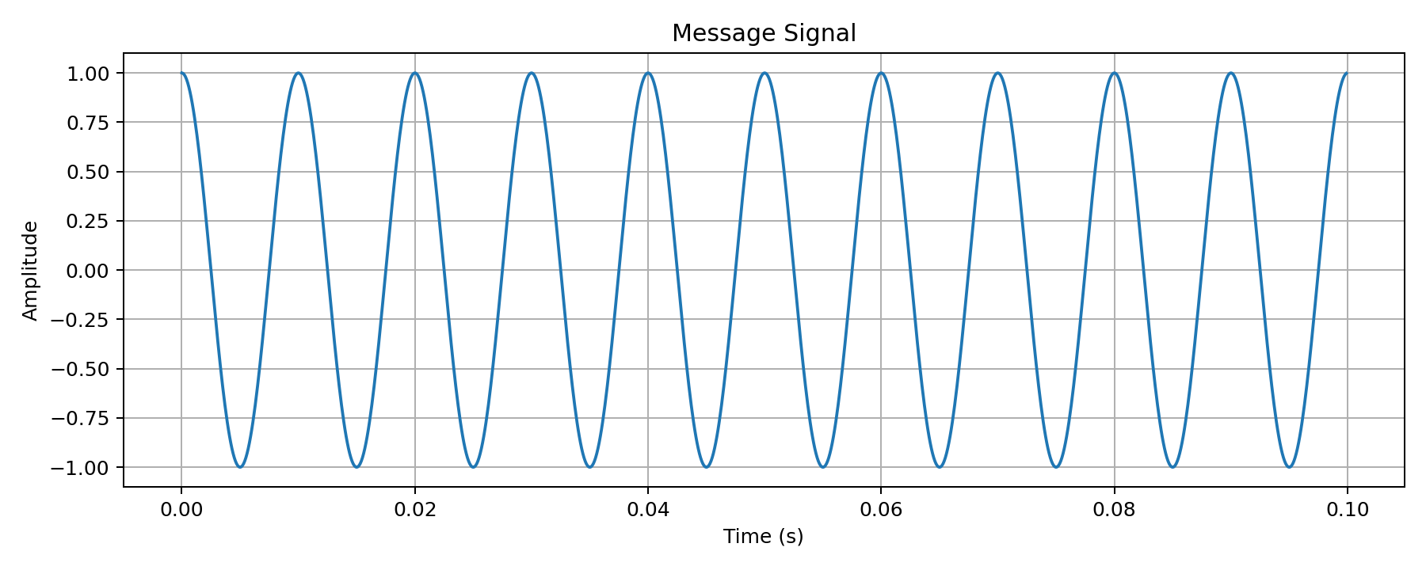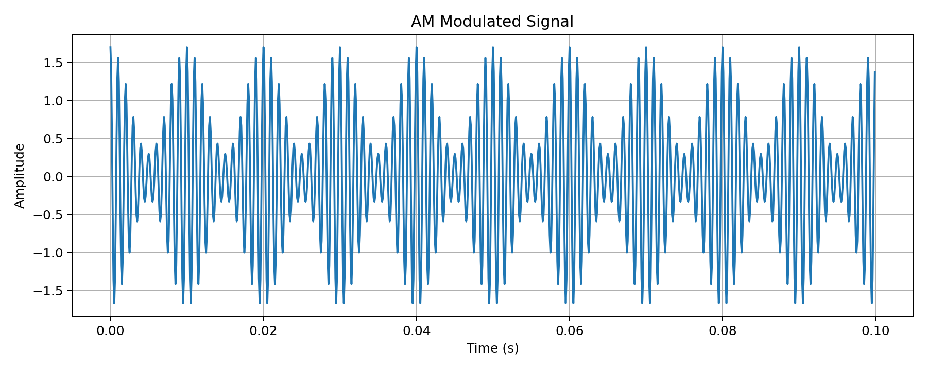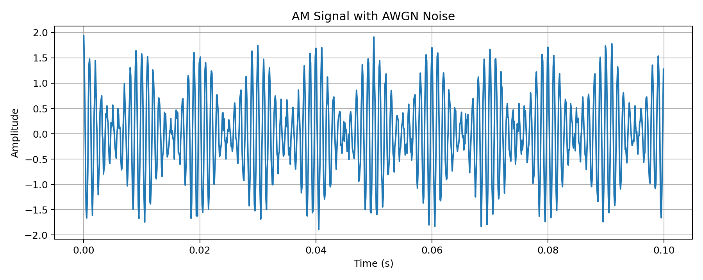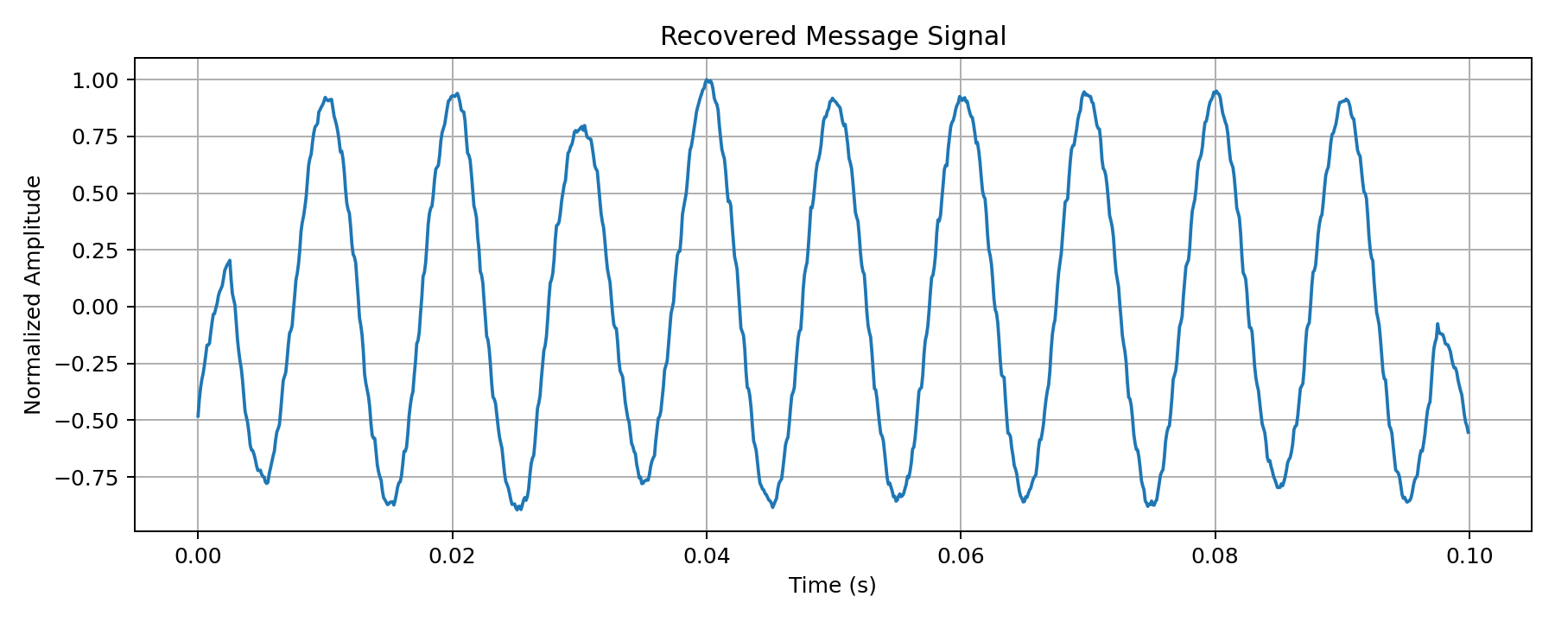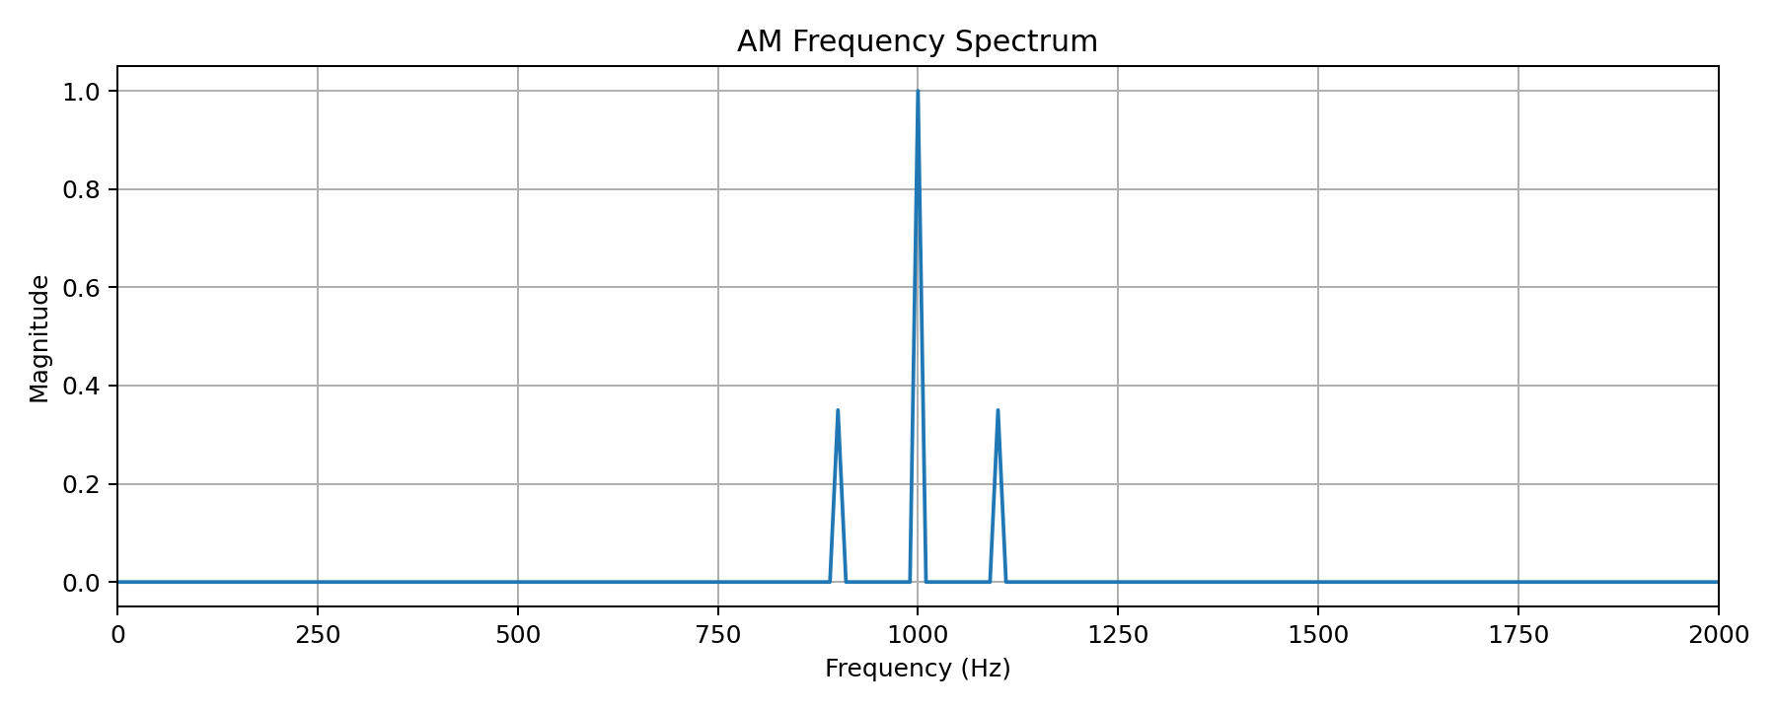

6. ANALYSIS AND ENGINEERING DECISION
6.1 Analysis
The simulation demonstrates that no single modulation technique is optimal for all communication applications.
SSB-SC provides better bandwidth efficiency than DSB-SC.
VSB-SC is suitable for television broadcasting because it provides a practical bandwidth compromise.
FM provides better immunity to amplitude noise and is suitable for audio broadcasting.
PCM provides reliable digital representation of voice signals.
BPSK provides good power efficiency, while QPSK provides higher data transmission efficiency. QAM provides high spectral efficiency but requires better SNR.
6.2 Channel Analysis
Condition | Effect | Solution
AWGN | SNR reduction | Increase SNR / suitable modulation
Fading | Amplitude and phase distortion | Equalization
Interference | BER increase | Filtering and channel allocation
Limited bandwidth | Signal distortion | Efficient modulation
Coarse quantization | Quantization noise | Increase quantization levels

6.3 Engineering Decisions
The following techniques are selected:
- SSB-SC for bandwidth-efficient analog communication
- VSB-SC for television transmission
- FM for high-quality audio broadcasting
- PCM for digital voice
- BPSK for robust low-power digital communication
- QPSK for improved spectral efficiency
- QAM for high-data-rate wireless systems
- Channel coding for error protection
- Equalization for multipath compensation
- TDM/FDM for multi-user communication
7. BROADER CONSIDERATIONS
7.1 Sustainability
The proposed communication system supports efficient utilization of communication resources. Spectral-efficient modulation and multiplexing reduce unnecessary bandwidth usage.
Energy-efficient communication techniques can reduce the power consumption of communication equipment.
7.2 Scalability
The architecture can be expanded to support additional subscribers and communication services.
The digital architecture allows new users to be added using additional time or frequency resources.
7.3 Reliability
Channel coding, equalization and suitable modulation techniques improve communication reliability under noisy and fading conditions.
7.4 Security
Digital communication systems can incorporate encryption, authentication and secure access mechanisms to protect transmitted information.
7.5 Industrial Applications
The proposed architecture has applications in:
- Radio broadcasting
- Television broadcasting
- Digital telephone networks
- Cellular communication
- IoT networks
- Remote monitoring
- VoIP
- Broadband communication
- 5G and future wireless networks
7.6 Future Enhancement
The system can be extended by incorporating:
- 5G/6G communication
- OFDM
- Massive MIMO
- Software-defined radio
- AI-based channel estimation
- Intelligent equalization
- Adaptive modulation
- Machine-learning-based signal detection

8. CONCLUSION
The proposed project successfully presents an integrated end-to-end Analog and Digital Communication System suitable for broadcasting, digital voice and next-generation wireless applications.
The system combines AM, DSB-SC, SSB-SC, VSB-SC, FM and PM for analog communication and sampling, quantization, PCM, DPCM, DM, ADM and ADPCM for digital voice communication.
Digital modulation techniques including ASK, FSK, BPSK, QPSK and QAM are evaluated based on bandwidth, SNR and BER. Multiplexing, channel coding, spread spectrum and equalization techniques are also incorporated to improve communication efficiency and reliability.
The system is validated under AWGN, fading, interference and bandwidth/quantization-limited conditions. Performance is evaluated using bandwidth, SNR, SQNR, BER, eye opening, spectral efficiency, coding gain and power efficiency.
The analysis shows that communication-system design requires a balance between bandwidth, power, reliability, complexity and data rate. Therefore, the appropriate modulation and signal-processing technique must be selected according to the specific application.
Overall, the project demonstrates the practical integration of analog and digital communication principles into a unified communication architecture for modern and future communication networks.

9. STUDENT REFLECTION
This assignment helped me understand how different analog and digital communication techniques are combined to build a complete communication system. Initially, the concepts such as AM, FM, sampling, PCM and digital modulation were studied separately. Through this project, I understood how these techniques work together in a practical transmitter-channel-receiver system.
I learned how bandwidth, noise, interference, fading and quantization affect communication performance. The simulation helped me understand the relationship between SNR and BER and showed why suitable modulation and coding techniques are important.
The analysis of BPSK, QPSK and QAM helped me understand the trade-off between power efficiency and spectral efficiency. The eye diagram provided a clear understanding of inter-symbol interference and timing performance.
I also understood the importance of multiplexing and channel coding in multi-user communication systems. Testing the system under AWGN, fading, interference and bandwidth-limited conditions improved my ability to analyse practical communication problems.
Overall, this assignment improved my knowledge of MATLAB/Simulink-based communication-system simulation and strengthened my ability to make engineering decisions based on measurable performance parameters.

10. REFERENCES
- Simon Haykin, Communication Systems, Wiley.
- B. P. Lathi and Zhi Ding, Modern Digital and Analog Communication Systems, Oxford University Press.
- John G. Proakis and Masoud Salehi, Communication Systems Engineering, Pearson.
- John G. Proakis and Dimitris G. Manolakis, Digital Signal Processing, Pearson.
- MATLAB Documentation, MathWorks – Communication System Simulation.
- MATLAB Communications Toolbox Documentation.
- MATLAB Signal Processing Toolbox Documentation.
- B. Sklar, Digital Communications: Fundamentals and Applications, Pearson.
- Theodore S. Rappaport, Wireless Communications: Principles and Practice, Pearson.
- ECA0804 – Analog and Digital Communication course material and assignment requirements.

11. COMMON COURSE ASSIGNMENT FORMAT / ASSESSMENT SECTION
COMMON ASSESSMENT RUBRIC
Criteria | Marks
Problem understanding and formulation | 10
Application of course concepts | 20
Design and implementation | 20
Use of modern tools | 10
Results and validation | 15
Analysis and engineering decision | 15
Broader considerations | 5
Conclusion and reflection | 5
Total | 100

CO–PO–ASSESSMENT MAPPING
Course Outcome | Assessment Component | Bloom's Level
CO1 | Analog communication architecture and modulation | L4
CO2 | FM/PM and noise analysis | L4/L5
CO3 | Sampling, quantization and PCM | L4
CO4 | Digital modulation, BER and signal-space analysis | L5
CO5 | Coding, multiplexing, wireless and equalization | L5/L6

STUDENT SUBMISSION DETAILS
Particular | Details
Student Name | Barath A
Register Number | 192312568
Programme | B.E./B.Tech ECE
Course Code | ECA0804
Course Name | Analog and Digital Communication
Assignment Title | Design, Simulate and Evaluate an End-to-End Analog and Digital Communication System for Broadcast, Digital Voice and Next-Generation Wireless Networks
Faculty Name | Dr. Uma
Date of Submission | 02-09-2026
Student Signature | 02-09-2026

FACULTY EVALUATION
Parameter | Maximum Marks | Marks Awarded
Problem Understanding | 10
Course Concept Application | 20
Design and Implementation | 20
Modern Tools | 10
Results and Validation | 15
Engineering Analysis | 15
Broader Considerations | 5
Conclusion and Reflection | 5
Total | 100

Final Submission Checklist
☐ Assignment report completed
☐ System block diagram included
☐ Parameter calculations included
☐ MATLAB/Simulink code included
☐ Simulation output included
☐ Waveforms and spectra included
☐ Eye diagram included
☐ Constellation diagram included
☐ Four test scenarios completed
☐ Performance metrics calculated
☐ Engineering decisions explained
☐ Reflection completed
☐ References included

